Git and Github -09

- Watch the video and write notes.
- Create a GitHub account.
- Set up MFA (Multi-Factor Authentication) for the GitHub account using a mobile app.
- Execute all commands shown in the video.

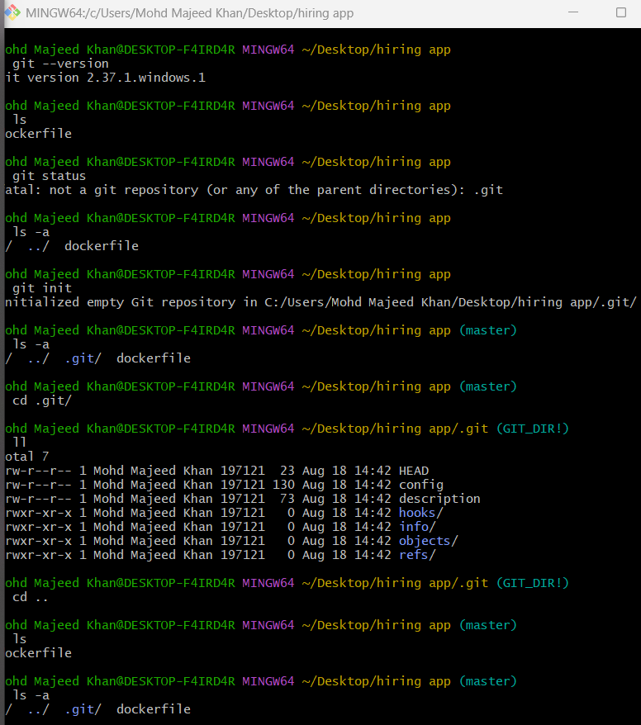
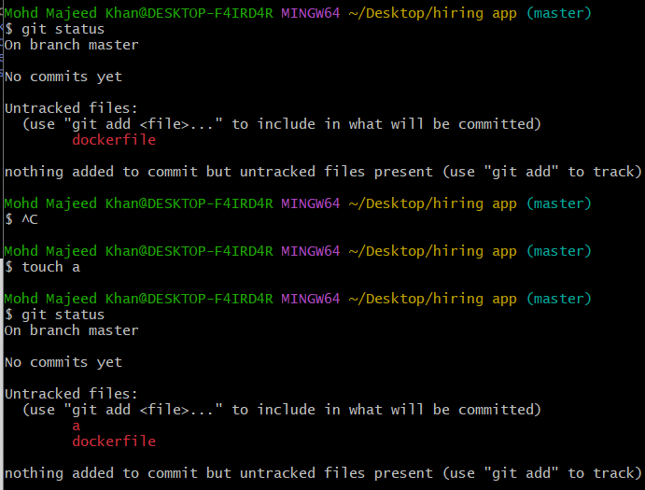
- $ git config --global –list / git config –list
- git config --global user.name "majeedkhan91"
- git config --global user.email "mohdmajeedkhan91@gmail.com"
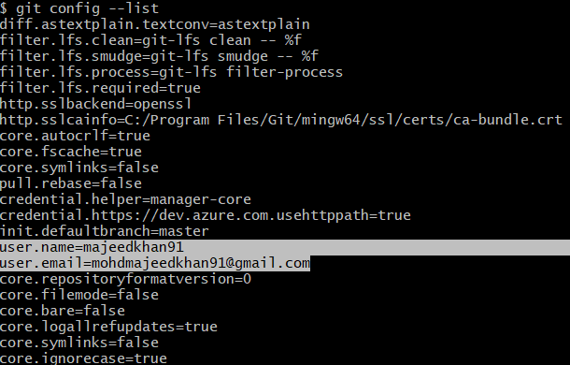
Untracked files to tracked files: (use "git add" to track)
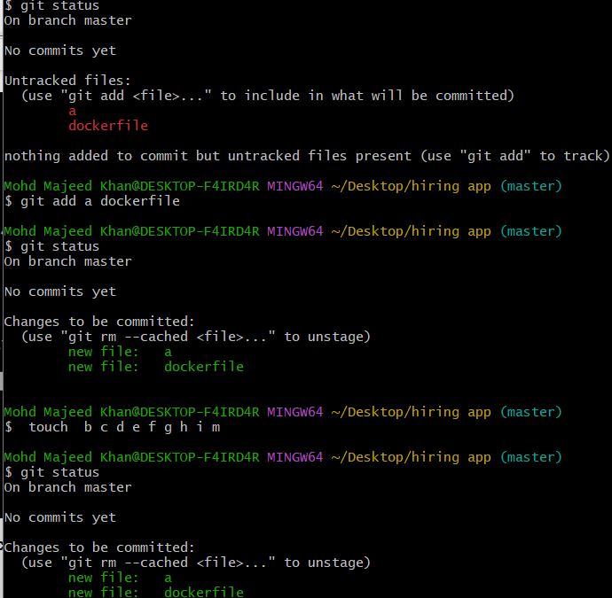
Untracked files to tracked files: (use git add . to track all files)
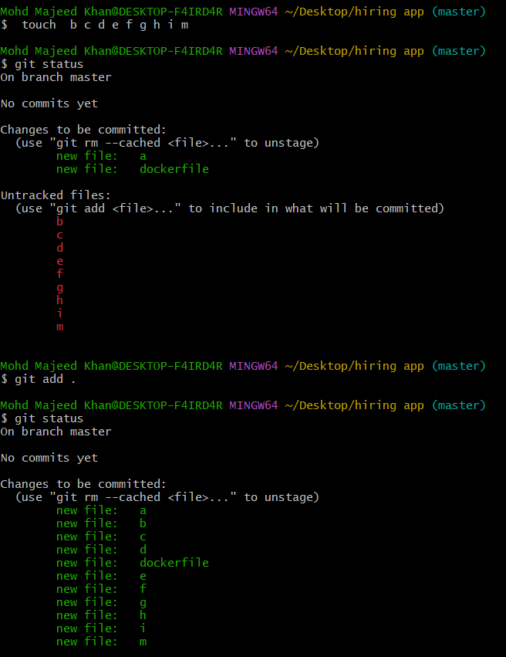
git status → Shows the current state of your Git repository, including changed, staged, and untracked files.
$ git commit -m "message" - $ git commit -m "added couple of files"
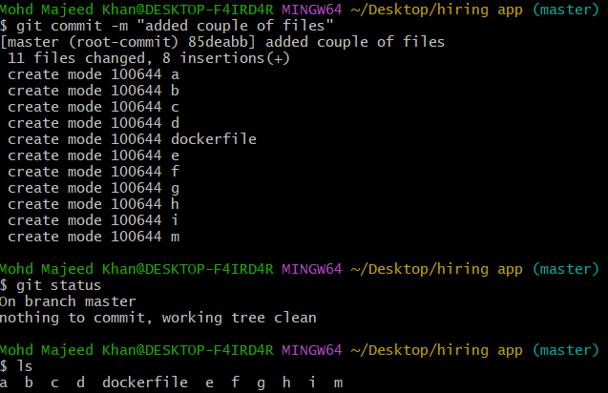
- git log is used to check commit id, author and date.
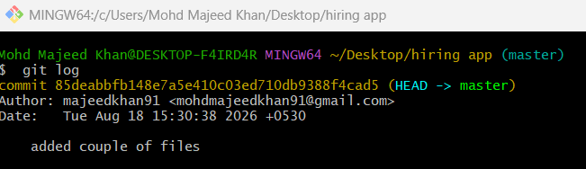

https://github.com/majeedkhan91/techie-horizon-09

git remote -v: Shows the remote GitHub repository URLs connected to your local Git project.

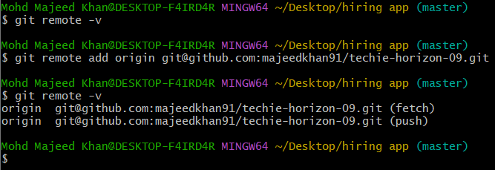
To created (publickey): ssh-keygen
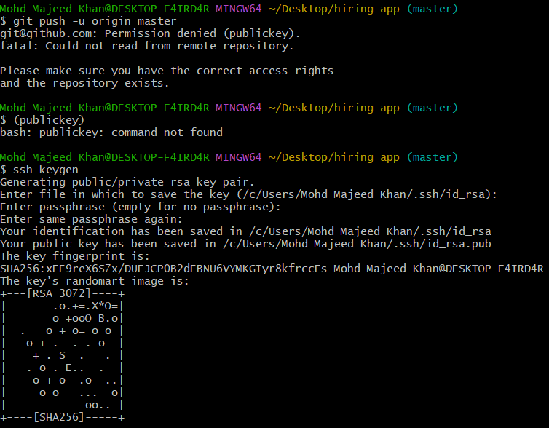
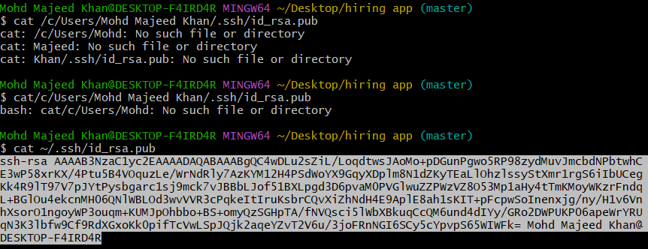
Copy key pair go to git hub account that was created settings on left side SSH and GPG keys New SSH key and paste key pair
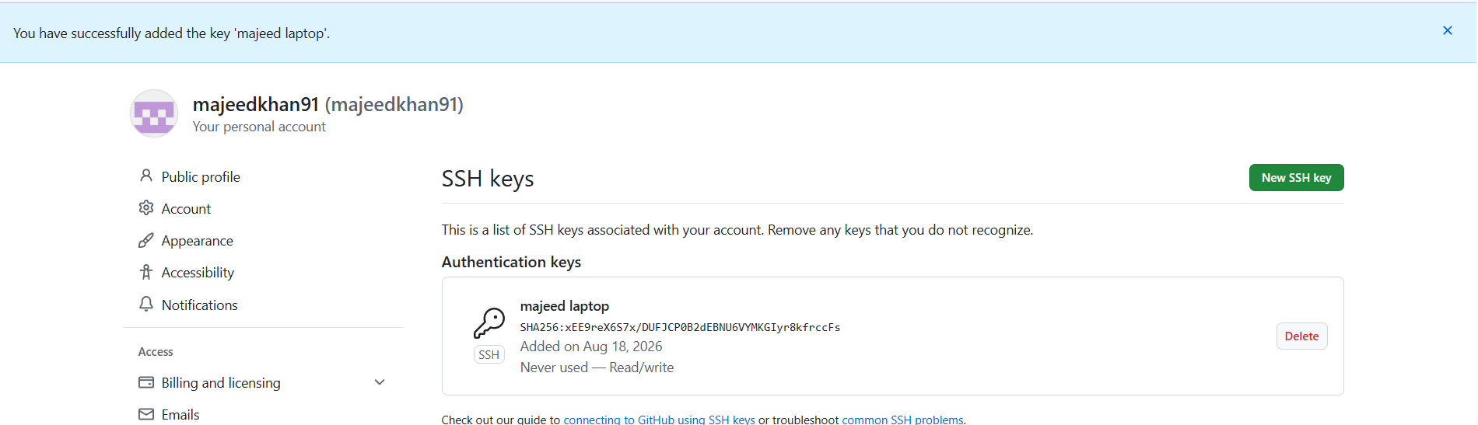
- To push: git push -u origin master
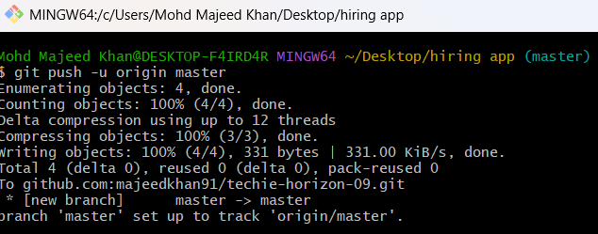
After this go to github refresh page will show below SS
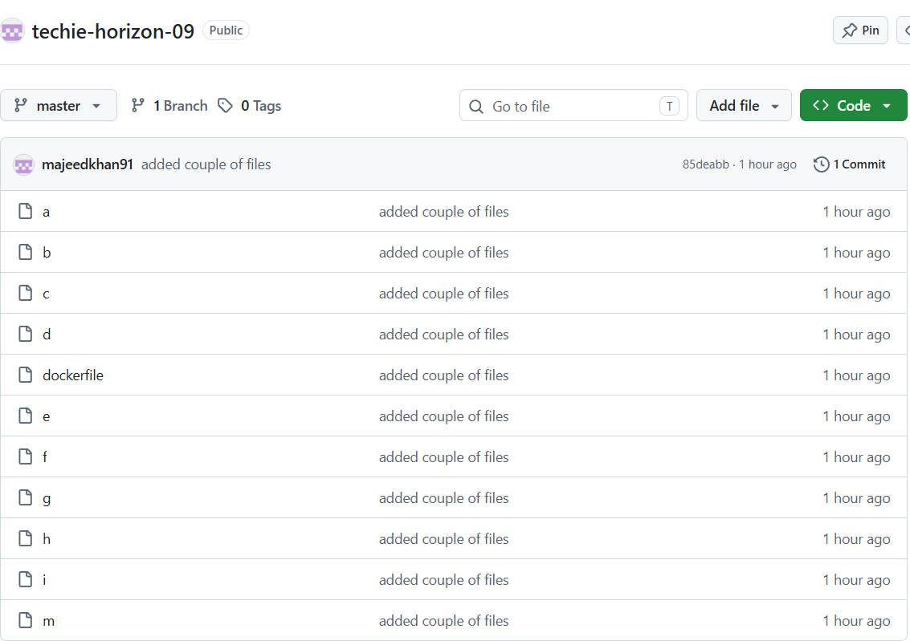

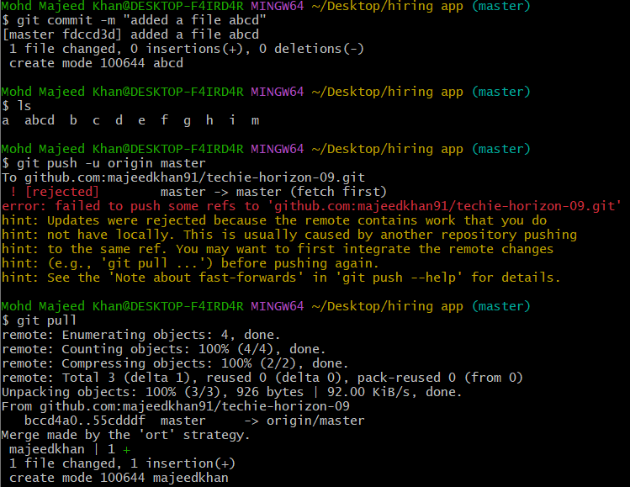
Git clone = Downloads the complete repository from GitHub to your local machine.
Use git log -4 shows all changes added or deleted one
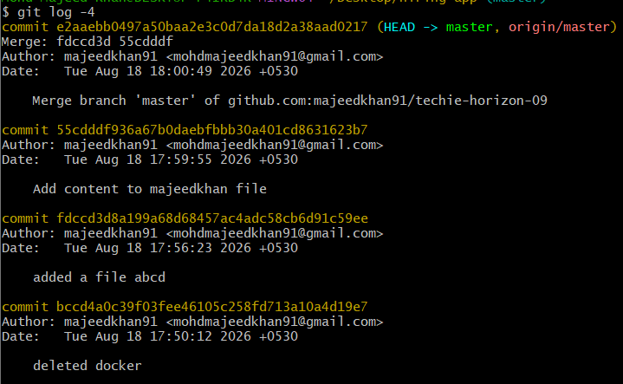
- Set up MFA (Multi-Factor Authentication) for the GitHub account using a mobile app.
- MFA/2FA is successfully enabled. ✅
